Before the activity we are creating a new table which name is **emp** and insert some values into the table see the below images.

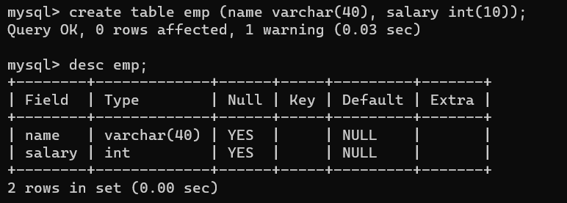

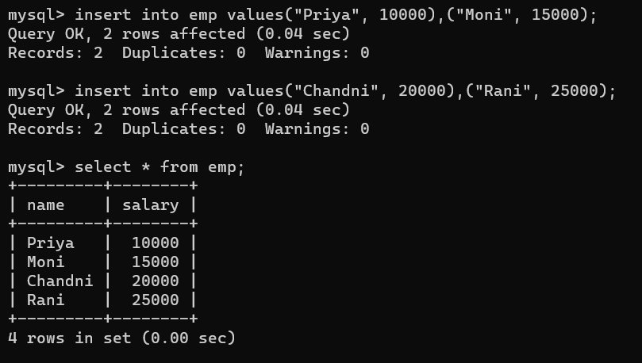

1. Perform transaction in database tables using commit and rollback operations.

**Commit :-**

Step -1: Type insert into emp values("Manoj", 2000),("Amit", 5000);

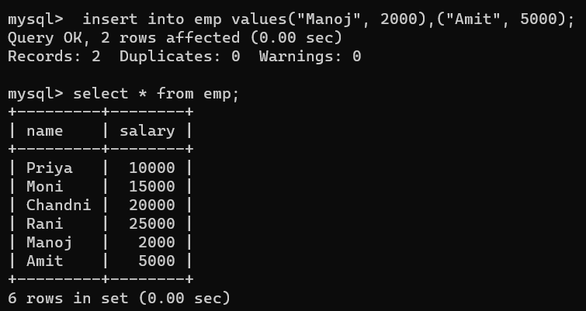

Step -2: Type commit; (commit cmd use for save the data) and type rollback;(rollback use for undo) Then type select * from emp; but here rollback not succeed because of commit.

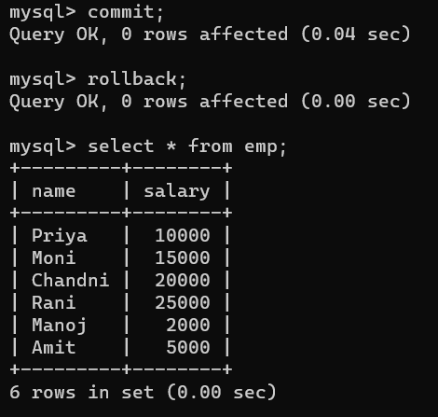

1. Demonstrate use of transaction control in relational databases (using Savepoint).

For savepoint you need to store more value into the **emp** table.

Step -1: Type **begin;** then **savepoint A;** (here savepoint is work like a bookmark).

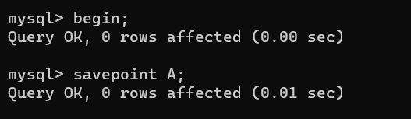

Step -2: Type insert into emp values("Manoj", 2000),("Amit", 5000);

Step -3: Type insert into emp values("Priyanka", 20000);

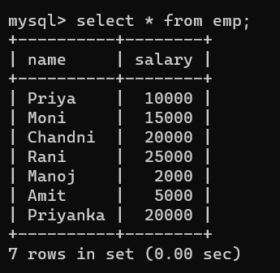

Step -4: Type rollback to A; and select * from emp;

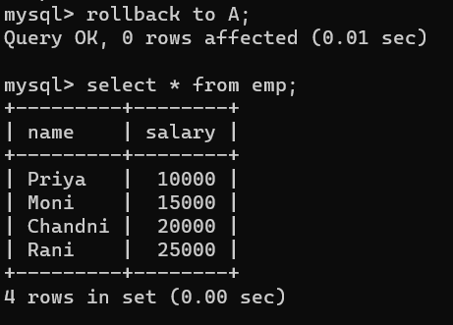

Here you can see last 3 values undo by the rollback to A.

1. Perform user management activities in MySQL database, create, modify user, set privileges.